Your 2nd Great Grand Mother "Moma Delia, A Tale of Love, Resilience, and HBCU Dolls"
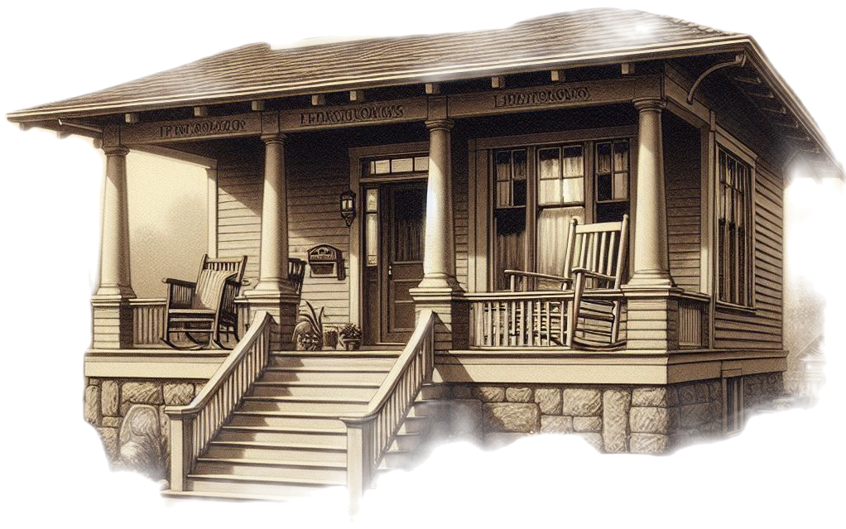
Once upon a time, in the heart of Coosa County, Alabama, a bright and spirited soul named Delia Kendrick Williams came into the world on July 24, 1889.

Delia's story unfolded like a patchwork quilt, rich with love, family, and the resilient spirit that defined her character.
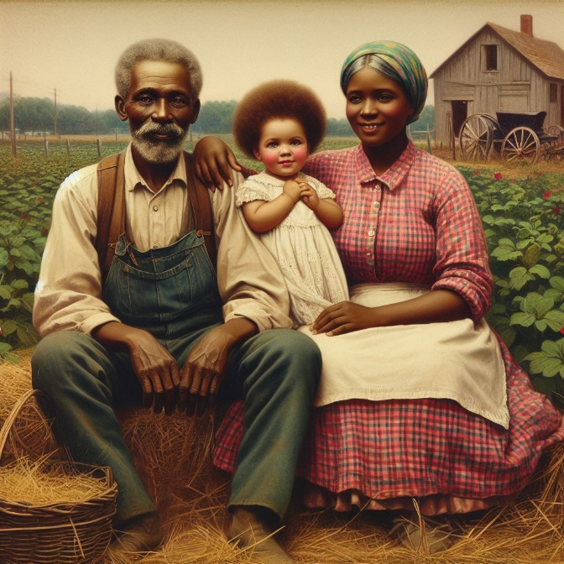
Delia's parents, Gilbert and Bama, welcomed her with open arms, setting the stage for a life filled with warmth and love. As she grew, so did her dreams, and on a special day in 1908, she married the charming Charley Williams from Autauga County.
Together, they embarked on a journey that spanned over five decades, bringing 13 wonderful children into the world.
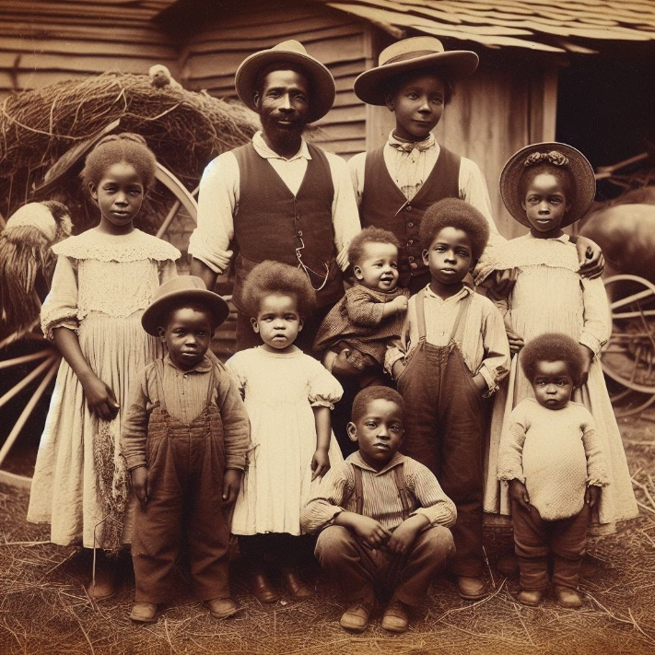
On a magical February day in 1922, Charley and Delia became proud owners of a 13-acre farm, where they planted roots and nurtured a life filled with abundance.
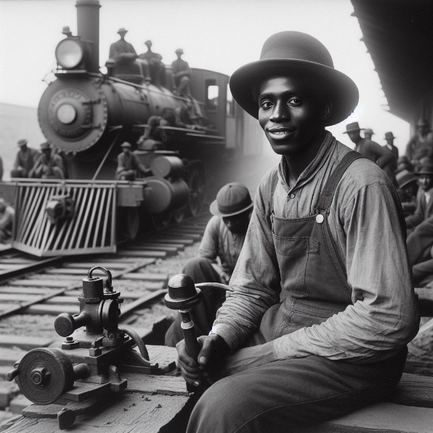

Charley, a hardworking man, also served as a section leader for the Louisville & Nashville railroad, providing for his growing family.

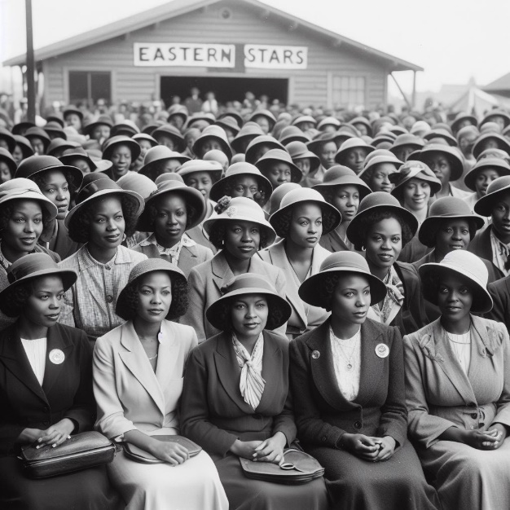
In 1926, Delia joined the Eastern Stars, a masonic group that stood for education, community service, and social support. For nearly five decades, she dedicated herself to uplifting others and building a stronger community.

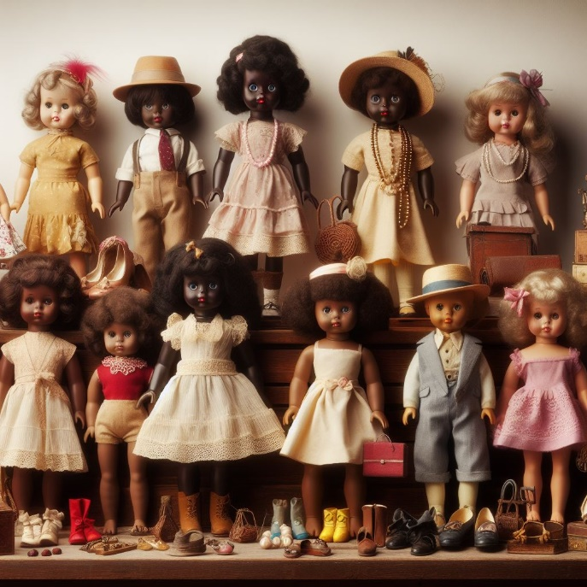
A true artisan, your 2nd Great Grandmother Moma Delia had a passion for dolls. Friends and family gifted her these cherished companions, and she lovingly crafted clothes for them, creating a world of beauty within her home. If she were here today, she would undoubtedly be dressing your HBCU dolls in outfits that celebrate culture and education.

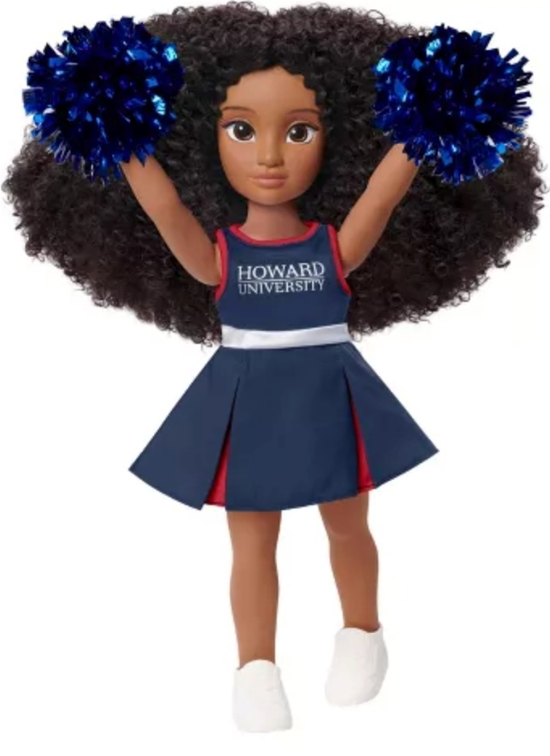
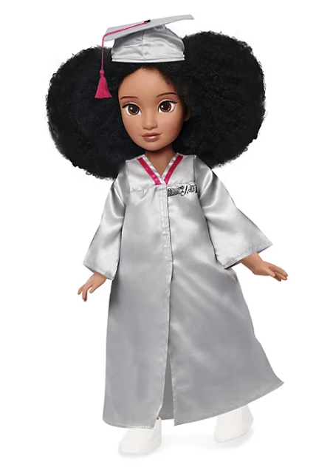


As time unfolded, the family faced challenges, including a devastating tornado in March 1932 that destroyed their home. Yet, in the face of adversity, Delia emerged as the pillar of strength, tending to the injured and ensuring that her family rose from the rubble stronger than before.
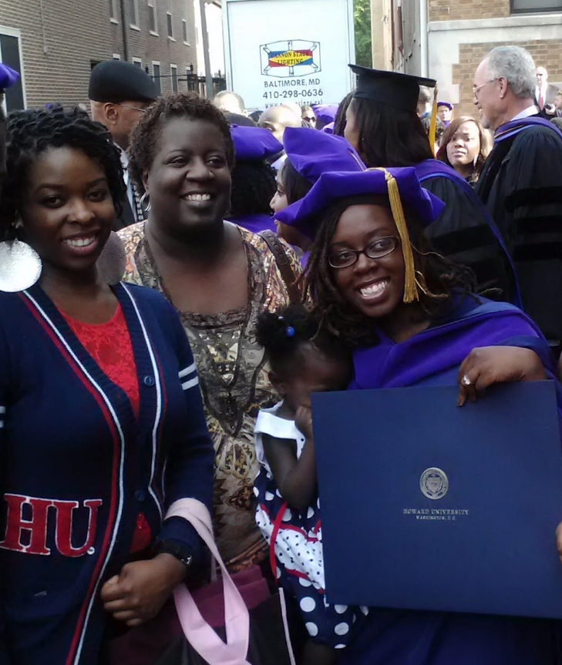
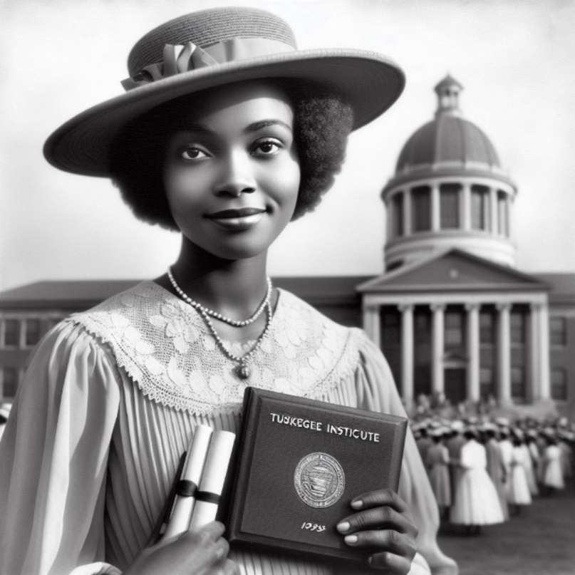
Delia's commitment to education echoed through generations. Her daughter Izora attended Tuskegee College, paving the way for her other daughters Annie Laura and Annie Bee to follow in her footsteps to attend college and become teachers. Meanwhile, her sons Robert, Charles, and Wiley bravely served in World War II.

Delia’s legacy of education continues all the way to the 20th century where your aunt Abeni and your mother Tamena are both graduates of the great HU, Howard University. CLICK HERE

Delia's nurturing spirit also extended beyond her immediate family. Her home became a haven for nephews, nieces, and countless grand children throughout the years. She showered them with love, always ensuring there were fruit, snacks, and joy to share.
In 1975, at the age of 85, Moma Delia Kendrick Williams left this earthly realm, leaving behind a legacy that transcends time. Her great granddaughter (your mother) Tamena, continues the tradition of community service, belonging to the esteemed Alpha Kappa Alpha sorority.
This season, as you hold these HBCU dolls in your hands, remember the extraordinary woman who stitched love into the fabric of her family's story. Moma Delia's legacy lives on in each of you, a testament to the enduring power of love, resilience, and the belief in a brighter future.

